Instructions for Vendorlink Reports:

1: Drill down into the “Reports” section from the main menu of Vendorlink.
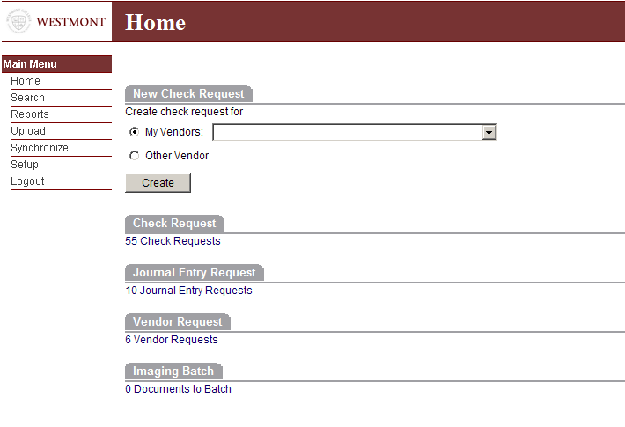

2: Choose the type of account you want to view under the words “General Ledger”.
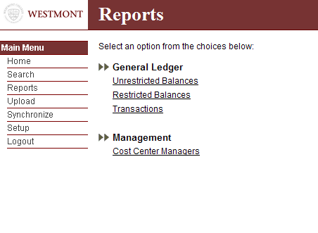
Unrestricted Balances begin with the number 11 and refer to your budgeted general ledger account series. Restricted Balances normally begin with either the numbers 13, 18, 29, 61 or 62. (There are other restricted account number series but they will be rarely used for this type of report). If you choose Transactions, you will be able to view only specific transactions within accounts.

***
Please note the “Management” section of Reports has not been activated yet. You will receive an error message until it is ready for use.

3: For this example I have clicked on the “Unrestricted Balances” Report.
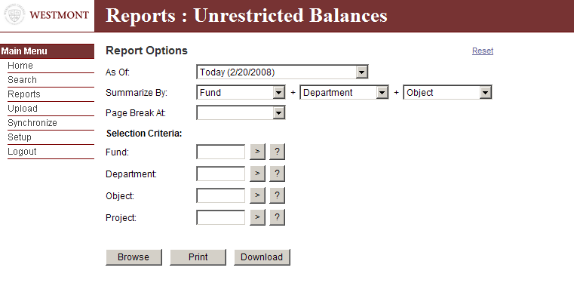
As soon as you see this screen, click on the 4 grey boxes with the ? inside. This will open up the drop down screens.
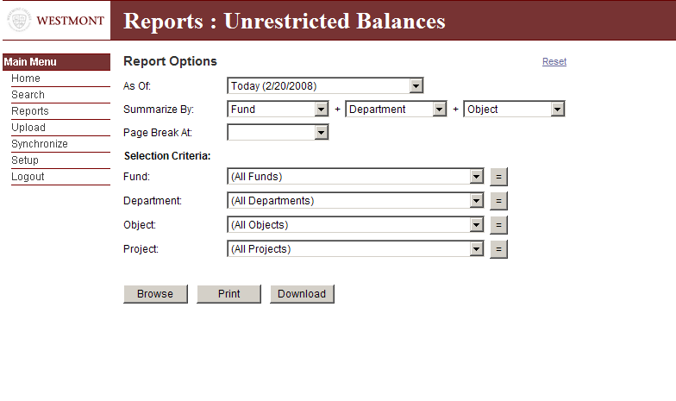

4: Choose your “Report” criteria.
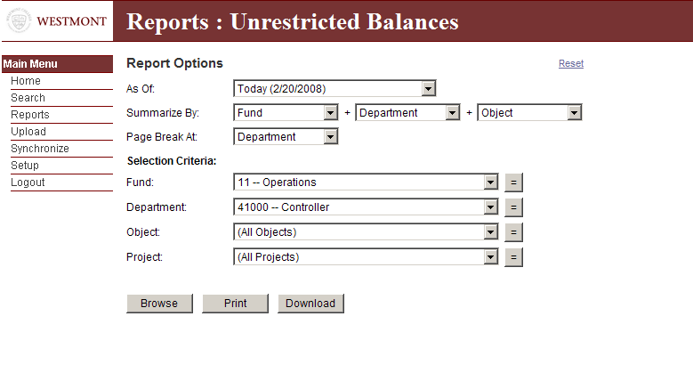
I recommend leaving the “Object Field and Project Field” with the default listed of (All Objects) and (All Projects). Then click Browse. This will bring up the standard report for a departmental budget.
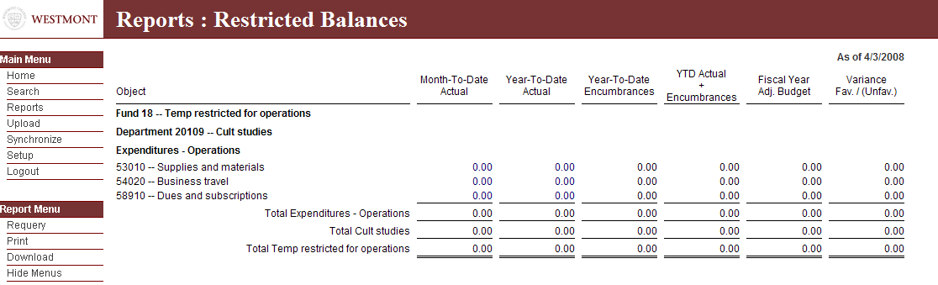

You can drill down into anything highlighted in blue to see more detail. You can also drill down into the document number or click on the paperclip if you would like to see the batch cover sheet and receipts and documentation for this transaction.

5: After choosing the Report criteria, other options are to Print, (Adobe PDF) or download into excel:

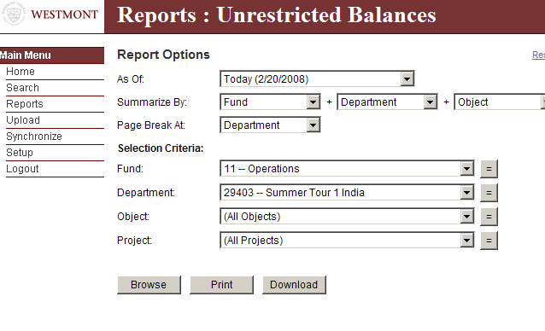
These are the basic instructions on using the Reports section of Vendorlink. If you have further questions, please contact Debbie Price, Candace Kim, Jim Reid or Paul Larson in the Business Office.

